**LED STRING ANIMATION_PO5_CYRS**

1. Content table

1. Content table 2

2. Document Status: 3

3. Document History: 3

4. Project Description: 3

4.1 Project Functionalities: 3

4.2 Block diagram: 4

5. Requirements description: 4

1. Document Status:

|  |  |  |  |
| --- | --- | --- | --- |
| Version | Author | Date | Status |
| 2.0 | Menna Mostafa | 6/2/2020 | Released |

# Document History:

|  |  |  |  |
| --- | --- | --- | --- |
| Version | Author | Date | Change Description |
| 1.0 | Menna Mostafa | 23/1/2020 | Initial Creation for  Structure of strings of LEDs used to provide Tail and TI functions based on some input signals. |
| 1.1 | Youssef Kamal | 25/1/2020 | As mentioned in review sheet.   * Changing document sequence. * Changing status section * Changing the header of the requirements section |
| 1.2 | Menna Mostafa | 29/1/2020 | Change Req_2 & Req_3 according to the review. |
| 1.3 | Youssef Kamal | 29/1/2020 | Adding Input Signal to Block Diagram |
| 1.4 | Mohanad Sallam | 4/2/2020 | Changing block diagram and removing unused tittles |
| 2.0 | Menna Mostafa | 6/2/2020 | Changing structure of requirements |

# Project Description:

This project consists of strings of LEDs in a certain pattern. The LEDs turn on/off based on input signals. The LEDs structure consists of two parts Tail and TI. Each Part will be activated according to the corresponding switches.

At Startup Mode there are two options (Modes):

* **First mode**: LEDs shall be ON from L6 to L1, then from R1 to R6 and vice versa, and then all LEDs are ON and OFF.
* **Second mode**: LEDS from R1 to R6 are ON LED by LED and also the left branch at the same time, and then repeat the scenario again.

## Project Functionalities:

Strings of LEDS are used to provide Tail and TI functions based on some input signals.

## Block diagram:

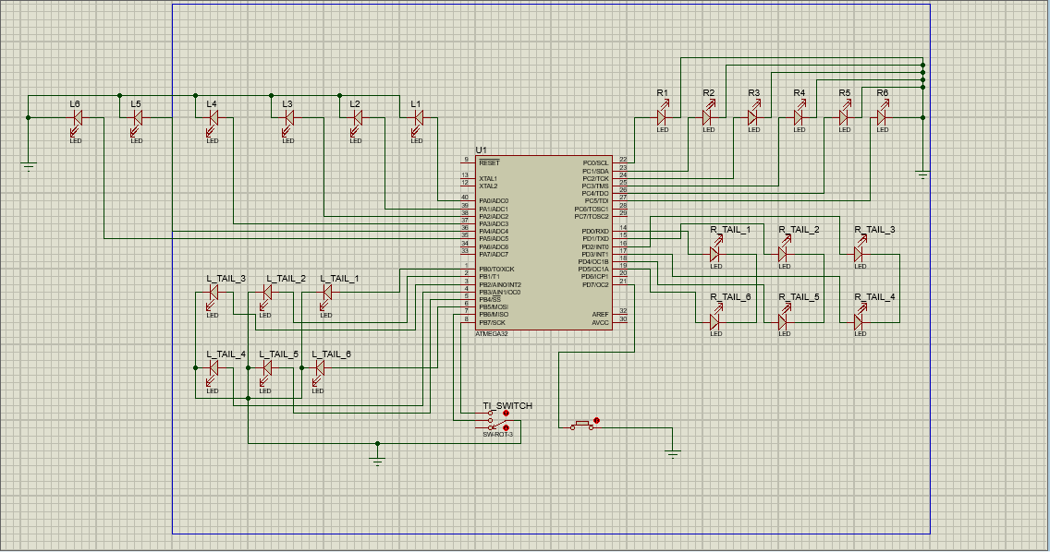

# Requirements description:

**Req _ SELECT WELCOME MODE_PO5_CYRS_001-V01 Imp # HW&SW**

If the switch is HIGH then the first mode in startup welcome will be selected and if switch is LOW the second mode will be selected.

**Req _ SEQUENCE OF WELCOME MODE ONE_PO5_CYRS_002-V01 Imp # HW&SW**

At system startup:

If the first mode is selected the system shall do the sequence:

All LEDS OFF except L6 is ON for 200ms

All LEDS OFF except L5 is ON for 200ms

All LEDS OFF except L4 is ON for 200ms

All LEDS OFF except L3 is ON for 200ms

All LEDS OFF except L2 is ON for 200ms

All LEDS OFF except L1 is ON for 200ms

All LEDS OFF except R1 is ON for 200ms

All LEDS OFF except R2 is ON for 200ms

All LEDS OFF except R3 is ON for 200ms

All LEDS OFF except R4 is ON for 200ms

All LEDS OFF except R5 is ON for 200ms

All LEDS OFF except R6 is ON for 200ms

Then

All LEDS OFF for 200ms

Then

All LEDS OFF except R6 is ON for 200ms

All LEDS OFF except R5 is ON for 200ms

All LEDS OFF except R4 is ON for 200ms

All LEDS OFF except R3 is ON for 200ms

All LEDS OFF except R2 is ON for 200ms

All LEDS OFF except R1 is ON for 200ms

All LEDS OFF except L1 is ON for 200ms

All LEDS OFF except L2 is ON for 200ms

All LEDS OFF except L3 is ON for 200ms

All LEDS OFF except L4 is ON for 200ms

All LEDS OFF except L5 is ON for 200ms

All LEDS OFF except L6 is ON for 200ms

All LEDS OFF for 200ms

All LEDS including Tail LEDS are ON for 300ms

All LEDS including Tail LEDS are OFF

**Req _ SEQUENCE OF WELCOME MODE TWO_PO5_CYRS_003-V01 Imp # HW&SW**

At system startup:

If the second mode is selected the system shall do the following sequence twice:

All LEDS OFF except R1, L1 are ON for 200ms

All LEDS OFF except R2, L2 are ON for 200ms

All LEDS OFF except R3, L3 are ON for 200ms

All LEDS OFF except R4, L4 are ON for 200ms

All LEDS OFF except R5, L5 are ON for 200ms

All LEDS OFF except R6, L6 are ON for 200ms

**Req _ SEQUENCE OF TAIL FUNCTION_PO5_CYRS_004-V01**

**Imp # HW&SW**

If Tail switch is HIGH then all Tail LEDS will be ON

And if Tail switch is LOW then all Tail LEDS will be OFF

**Req _ SEQUENCE OF TI FUNCTION RIGHT_PO5_CYRS_005-V01 Imp # HW&SW**

If right TI switch is HIGH then the system shall do the following sequence:

R1 will be ON then wait 200ms

R2 will be ON then wait 200ms

R3 will be ON then wait 200ms

R4 will be ON then wait 200ms

R5 will be ON then wait 200ms

R6 will be ON then wait for right TI switch to be released

**Req _ SEQUENCE OF TI FUNCTION LEFT_PO5_CYRS_006-V01 Imp # HW&SW**

If left TI switch is HIGH then the system shall do the following sequence:

L1 will be ON then wait 200ms

L2 will be ON then wait 200ms

L3 will be ON then wait 200ms

L4 will be ON then wait 200ms

L5 will be ON then wait 200ms

L6 will be ON then wait for left TI switch to be released